Clean-up of instruments on 4th floor 1522

As part of a clean-up in the laboratories at 4th floor 1522 there are several instruments which are no longer in use. These instruments are listed below. If you have an interest in one or more of these instruments then please let Jakob Mikkelsen (Jakobmik@phys.au.dk, 1522-422) know before 10th of July 2020 as they will otherwise be dismantled.

List of instruments which are not in use
Instrument 31. Room 413  Sputtering instrument. It had been connected to ASTRID.  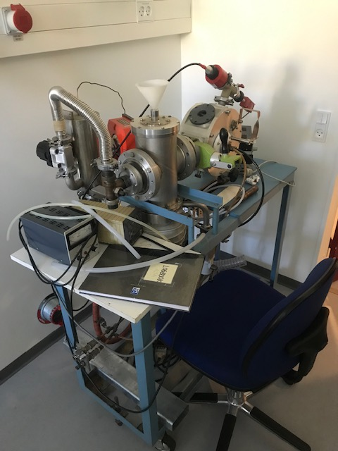 | Instrument 29. Room 413  Sputtering instrument.  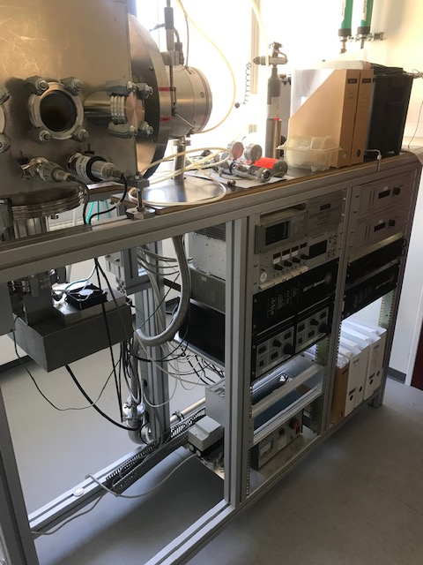
Instrument 28. Room 413  Incomplete characterization instrument. The use is unknown.  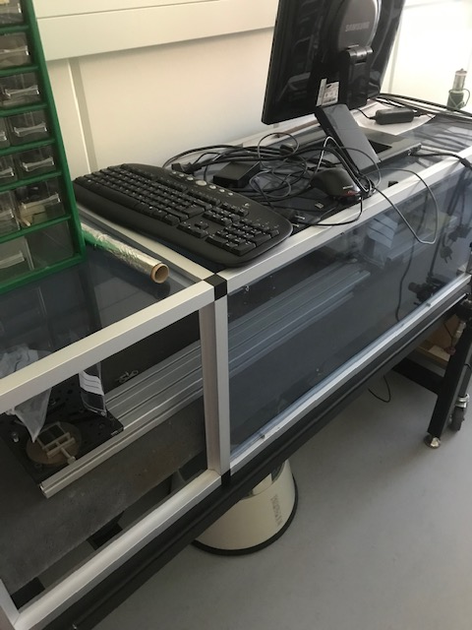 | Instrument 25. Room 415  Evaporation chamber.  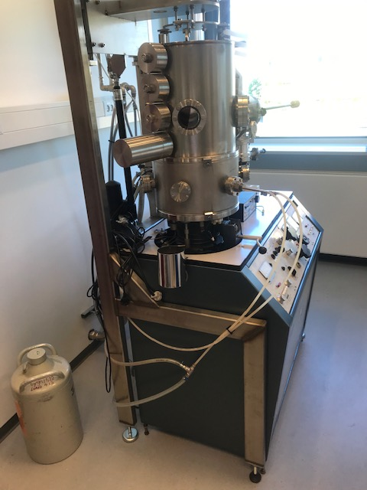
Instrument 24. Room 415  Double evaporation chamber, it is incomplete.  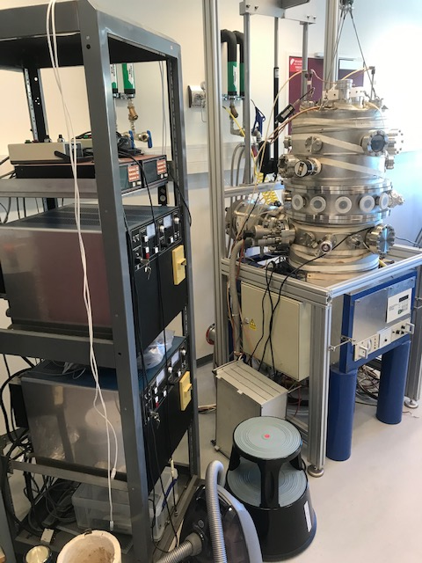 | Instrument 19. Room 419  Evaporation chamber. It had been used to evaporate LiF.  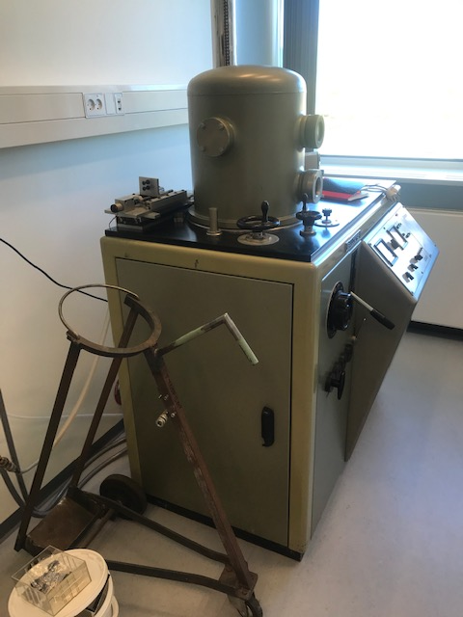
Instrument 18. Room 419
Evaporation chamber. It had been used to evaporate carbon.
