Centres of Excellence SIGMA Seminar series

“The mechanism of neurotransmitter: sodium symport – a crystal clear tale of two substrates”

Presented by:

Dr. Matthias Quick
Dept. of Psychiatry & Division of Molecular Therapeutics
Colombia University College of Physicians and Surgeons
Columbia University, New York
USA

April 16th, 2009, 15.00-16.00

The Lakeside Lecture Theatre, Aud. 3
(Søauditorium, Aud. 3.)

Everyone is welcome!

Hosted by:

Prof. Poul Nissen Center for Membrane Pumps in Cells and Disease - PUMPKIN
Aarhus University
Phone: 8942 5025 ; email: pn@mb.au.dk

Organized by:

The Lundbeck Foundation Research Centre MIND
The Danish National Research Foundation Centres PUMPKIN and inSPIN



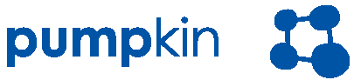

Sponsored by:
