WP5 Demonstrator for MADE REACT 2026

Introduction
This document describes the demonstrator environment for Work Package 5 (WP5) in the MADE REACT project.
The proposed demonstrator is planned in three phases. By April 2026 a baseline demonstrator that acts as a reference of the current state-of-practice in manufacturing lines in Denmark. In April 2027 a midway demonstrator for the testing and validation of intermediate results along with feedback on factory layout design and conceptualization. And finally, the third phase by the end of 2028 delivers the final demonstrator that provides the complete platform for the testing of the whole project and its research objectives.
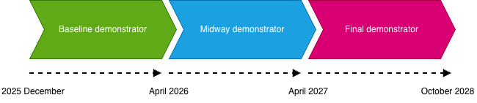
Figure 1 Demonstrator Timeline
To build up the demonstrator in the AAU Smart Production Lab there are five physical systems available:
- FESTO Line: A modular and reconfigurable line that can produce dummy phones with low variance but high volume (HVLM).
- Matrix Table: A matrix production system that also produces the same dummy phones at high variances, but at very low volume (HMLV).
- Manual Assembly Station: An operator at this station produces some variants of the dummy phones at low volume.
- Quality Control Station: A standalone table equipped with a PC and a camera for manual operator quality check.
- AMR: Mobile robot equipped with an UR5 robot.
Using these main elements, the demonstrator environment will establish a miniature factory producing a dummy phone product with a high product variability. The different elements will allow for creating both dedicated manufacturing lines, highly flexible production lines, manual processes, and both manual and automated logistics.

Research Scope
Both the final, midway and baseline demonstrators represent the current state-of-practice of manufacturing lines. They serve as a foundation for new research, where research on the following topics can be conducted:
- Integrated planning and scheduling with dynamic routing with changeable topologies
- Software driven production on the IT/OT level
- Design of resilient reconfigurable systems
- High mix low volume and low volume high mix operations
- Discrete Event Simulation (DES), industrial metaverse and virtual commissioning
- Researcher involvement in both the design and operations phases
- Possibility for data collection and analysis
- IIOT data collection and AI based data analytics
- AR operator guidance and trouble shooting
- Regionalization

FESTO Line
The Smart Production Lab at Aalborg University features a FESTO Didactic Smart Production Line, a modular and reconfigurable setup originally designed for Industry 4.0 research and education. It enables experiments with automated assembly, logistics, and quality control, supporting both physical and virtual integration for digital twin development. It was originally installed at the university Smart Production laboratory in 2016. It produces simple dummy phones.
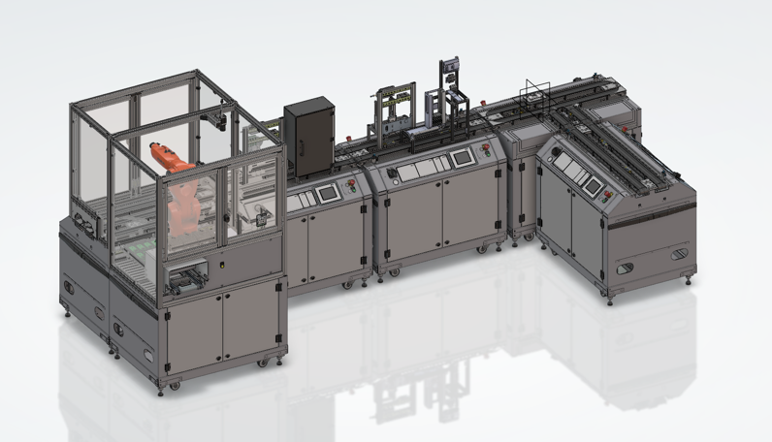
Figure 2 FESTO Line 2026
In late 2025, the line is built up of 5 distinct modules. The modules are connected with a conveyor belt carrying a small pallet. This small pallet carries the phone along the assembly processes. The pallets move along the line automatically and stop at one of six process stations, such as inserting the covers, PCBs or fuses. One of the stations, a robot cell inserts two fuses into the phone PCBs. Before the last station the phones are quality checked with a camera, then transported to an outbound station where currently a manual process removes the completed phones from the line.

Matrix Table
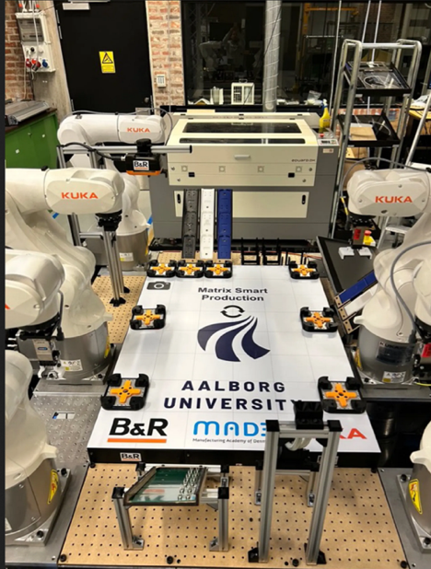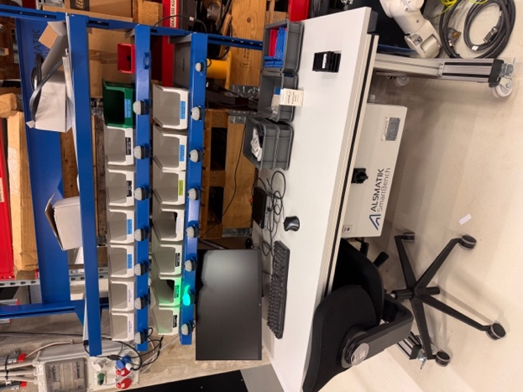
Figure 3 Matrix Table and Manual Assembly Station

Automated Mobile Robot (AMR)
Industrial robot platform that has a table with a UR5 on it equipped with a camera for dynamic pick and place.
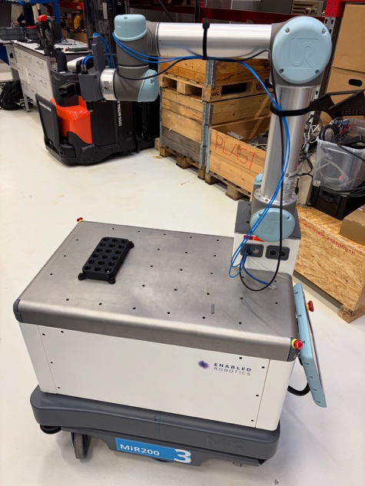
Figure 4 AMR with UR5

Manual Assembly and Quality Control stations
Alsmatik A/S custom built manual assembly and disassembly station, see Figure 3. The operator of the table follows light guided, and motion sensed cue to assembly a variant of the dummy phone. The table also has a PC that can access various automation databases for production schedules and upcoming orders.
The quality control station is placed by the side of the manual assembly station. The QC station also has a PC and an overhead camera for reporting and measuring faults.

Product: Dummy Phone Variants
There are in total 14 different predefined dummy phone variants the FESTO line or the Matrix Table can produce. A standard dummy phone is assembled from three main components: a Bottom and Top cover (in matching colors) and a PCB. The PCBs comes in two colors, blue and green. Each PCB can take either, 0, 1 or 2 fuses. It is also possible to 3D print new colors of the covers to increase the number of variants.
The following image shows a breakdown of an example dummy phone:
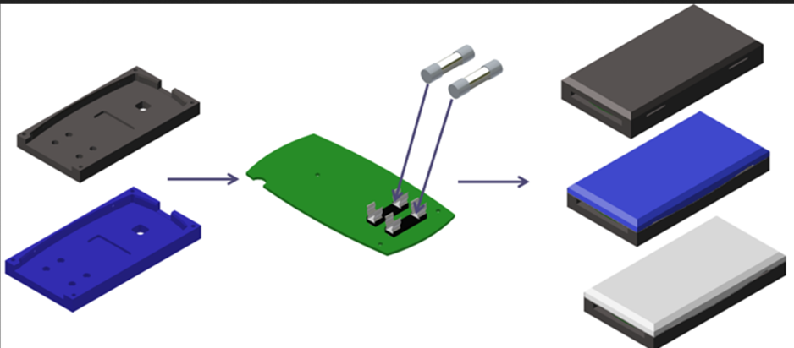
Figure 5 Dummy phone components and assembled examples

Currently available cover color and manufacturing options:
Cover Color | Molded | CNC machined | 3D printed
Black | x | x | x
Dark Blue |  | x
White |  | x
Light Blue | x
Pink | x

Final demonstrator overview
For the final demonstrator, we propose a miniature factory layout setup that has both virtual and physical components. The available systems in the lab will be integrated into a single system, connected by logistical operations with AMRs or other dynamic routing methods. A quality control station will be added at the end of the processes which will represent real world testing and quality assurance of finished products. The proposed factory flow can be seen in this graph:
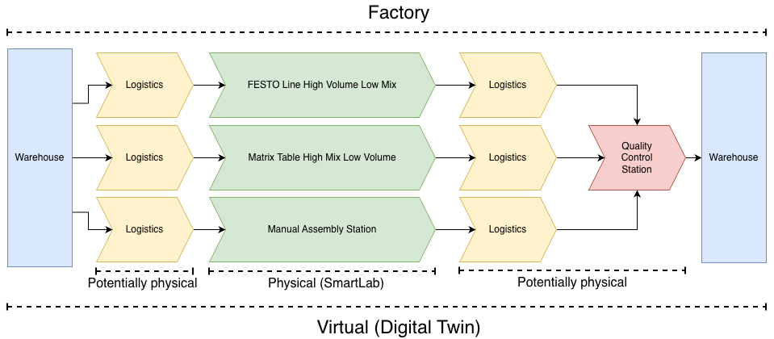
Figure 6 Demonstrator factory flow

Production scenario in final demonstrator
To be determined...

Midway demonstrator
The midway demonstrator represents an intermediate step between the baseline demonstrator and the final demonstrator. While its exact configuration is still under consideration, it will include additional complexity beyond the baseline demonstrator for testing of more advanced concepts and factory design strategies. A proposed layout is shown in the following graph:
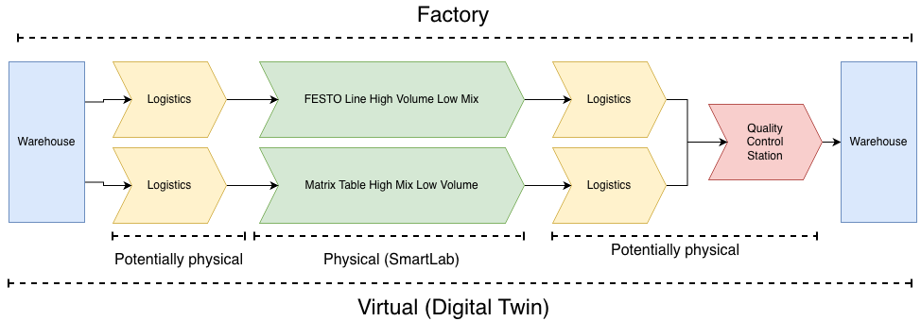
Figure 7 Midway Demonstrator

Production scenario in midway demonstrator
To be determined...

Baseline demonstrator
To establish a reference point for the project, we propose the following baseline demonstrator. This initial setup will focus on a single production system, FESTO line, along with essential supporting components such as basic logistics and a minimal quality control station. By limiting complexity, we enable an incremental expansion of the demonstrator with all researchers and other stake holders in the loop, as well as create a clear proof of concept. The reduced baseline factory flow can be seen in the following graph:
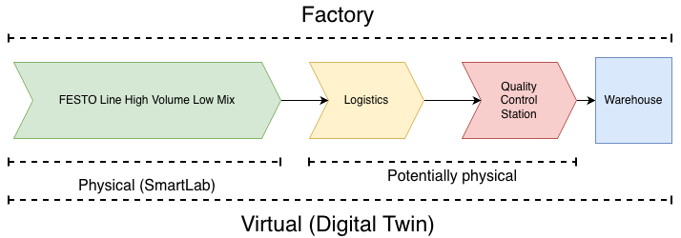
Figure 8 Baseline demonstrator factory flow

Production Scenario for Baseline Demonstrator
The FESTO line is going to be used as a mixed production line despite being designed for low-mix, high-volume manufacturing. This requires many changeovers involving manual work. While a significant amount of IIOT data is being collected, there is no real analytics being performed on it. The system uses the FESTO MES with pure FIFO scheduling, and there is no high-level orchestration layer. Instead, there are direct custom connections from specific stations to robots and the QC station.
The system provides only a digital shadow rather than a true digital twin, which means it is not real-time and difficult to use for effective debugging or commissioning of new processes. Additionally, operators require extensive training to perform troubleshooting tasks effectively.

Elements in the baseline demonstrator
The baseline demonstrator will only include a subset of the manufacturing elements from the final demonstrator. This includes:
- Assembly process
  - FESTO line
    - HMLV production line with few variants of the dummy phone.
    - Line has limited flexibility, changeovers required
- Logistics operation
  - Transport of parts to production Quality Control station.
  - Either functional AMRs or manual representation in the lab of a virtual operation.
- Quality Control station
  - Quality Control of assembled phones.
- Outbound warehouse
  - Storage of completed dummy phones.

External software and equipment providers
The baseline demonstrator is going to have CIM A/S provided their Catch.AI data collection system installed on an edge server close to the FESTO line. This will enable researchers to use the data directly from the FESTO line in their individual digital twin efforts and to aggregate large amounts of recorded data directly from the FESTO line PLCs for analytics purposes.

Interfaces to baseline demo
Each demonstrator provides multiple interface points where researchers can interact with the system. These are both digital and physical interfaces:
- Disturbance Injection
  - Inject controlled disturbances to simulate machine breakdowns, delayed parts, network latency.
- Dynamic Logistics and Routing
  - Access to dynamically reroute the AMRs and parts when disturbances occur.
- Planning and Orchestration
  - Adjust the production schedule, resource allocation, and workflow orchestration of all operations and processes.
- Quality Control Feedback
  - Evaluate impact of quality measurements on products later in the line.
- Data Layer Access
  - Collect, analyze, and inject data into IT/OT systems to test analytics, interoperability, and data-driven decision-making.
- Topology Reconfiguration
  - Change layout or connectivity of modules (physical and/or virtual).
- Industrial metaverse
  - Access to digital twins and live connections to industrial metaverse applications such as Nvidia Omniverse.

Demonstration scenarios, KPIs and measurements
The following scenarios establish baseline performance metrics for the production line in its current state-of-practice configuration. These measurements will serve as reference points for evaluating improvements from WP5 interventions into the later demonstrators.

Scenario 1: Nominal Operation Baseline
Motivation: A general performance baseline is needed. I.e. here we will measure traditional production KPIs such as lead time, makespan, OEE, etc. This is relevant to compare the general performance of the demonstrator to later demonstrator versions, and it is relevant in particular for the researchers working on operational planning and scheduling.
Objective: Establish baseline performance metrics under normal operating conditions without disturbances.
Configuration: Standard production run with current FESTO MES (pure FIFO scheduling), digital shadow only
KPIs:
- Makespan
- Lead time
- Succes rate
- OEE
Measurements:
- IIoT data collection for nominal operation definition
- Production KPIs through the FESTO MES4 system.
- Extended operation period to ensure representative data

Scenario 2: Changeover Performance and Priority Order Handling
Motivation: The FESTO MES4 control system has limited scheduling and planning capabilities and currently runs a purely FIFO scheduling approach. We will measure the performance of the system under high mix conditions both with and without allowing variant batching. This will induce manual changeovers on some proces stations. Furthermore, priority orders currently require extensive manual focus to expedite. Given the constraints of the current system and the research on planning and scheduling in WP1 + 4, this will serve as a baseline for the flexibility of the system to handle varying order demands.
Objective: Quantify changeover efficiency and system response to priority order disturbances under current manual changeover processes.
Configuration: Production run with multiple product batches requiring changeovers. Mid-run priority order injection to test current scheduling limitations.
Disturbances:
- Priority order insertion during production
KPIs:
- Makespan with changeovers
- Time spent on manual changeovers
- Priority order lead-time
- Time lost due to disturbances
- OEE
Measurements:
- IIoT data collection for nominal operation definition
- Production KPIs through the FESTO MES4 system.

Scenario 3: Fault Detection
Motivation: Data collection, visualization and analysis is expected to provide the insight into the system to ensure faster and more accurate fault detection. Therefore, we will measure the baseline where faults are detected purely by the operators relying on expertise and physical debugging in the system.
This baseline is further relevant to the digital twin implementations providing extended fault detection and analysis. Here, currently a digital shadow is available for the production line, and therefore a second baseline measurement will be made where a digital shadow is used for fault detection.
Objectives:
1) Assess the fault detection time and complexity relying solely on operator expertise and deductive capabilities on the physical system.
2) Assess the transparency and debugging capabilities providing a digital shadow of the production line.
Configuration:
1) Production run using only MES and PLC-HMIs for fault diagnosis. Controlled fault injection to test system visibility and operator response.
2) Production run using digital shadow for monitoring. Controlled fault injection to test system visibility and operator response.
Disturbances:
- Injected faults (sensor errors, quality defects, or station malfunctions)
KPIs:
- Time to identify faults
- Level of expertise/experience required (qualitatively evaluated)
- Lost productivity
- State synchronization accuracy (digital shadow vs. physical system)
- System transparency and insight limitations (qualitative assessment of debugging difficulty)

Measurements:
- Digital twin and physical twin comparison
- MES4, HMI information
- Operator insight
- IIoT data availability and usefulness during fault events

Scenario 4: Fault correction and maintenance
Motivation: Research in WP4 will focus on utilizing augmented reality (AR) to support operators in maintenance tasks. For that, we need a baseline measurement of operator performance without this support.
Objective: Establish baseline for operator troubleshooting performance using manual dashboard-based fault detection methods.
Configuration: Hidden fault injection during production with operators using only existing dashboards and standard operating procedures for diagnosis and resolution.
Disturbances:
- Hidden faults requiring operator diagnosis
KPIs:
- Time to react and identify faults from dashboards
- Total troubleshooting time (detection to resolution)
- Correctness of fault identification (diagnostic accuracy)
Measurements:
- Ease of use assessment of current dashboard-based approach

Scenario 5: New product variant and new equipment introduction
Motivation: Research in WP1 focuses on the design of production systems to meet resilience and HMLV requirements. The FESTO line is designed using a modular and reconfigurable approach, albeit with limited built-in flexibility. We will simulate the introduction of both a new product variant and the introduction of a new manufacturing module.
Objective: Establish a baseline for the time and effort required in introducing new product variants and new equipment. This includes a measure for development effort and commissioning effort.
Configuration: New product variants are introduced, new production equipment is introduced, and the effect on the system is evaluated qualitatively using virtual and conceptual models.
Disturbances:
- New product variants (of varying complexity)
- New production equipment
KPIs:
- Systems ability to handle new variants and equipment
- Development effort

Measurements:
- Reusable process stations given product variant introduction
- Number of system alterations needed given product variant introduction
- Estimated design and development effort given product variant introduction
- Estimated design and development effort given new production equipment
- Integration and commissioning time (estimated) for new production equipment

