A Practical NMR Guide
To optimize the sample throughput at the NMR the following suggestions are made:
- General: Clean NMR tube with homogenous, 550 µL sample solution
(4 cm solution level in NMR tube).
- ¹H NMR: 8 Scans are now the standard setting (sufficient for sample concentrations until ca. 5 mM).
- ¹H and ¹³C NMR: If a proton and a carbon spectrum is desired, prepare a 100 mM sample. First, run a standard proton NMR¹ (day queue), then later, a 128-scan carbon NMR (night queue).
- Full characterization: For a ¹H, ¹³C, COSY, HSQC² and HMBC, prepare a 50 mM sample and choose the following five experiments (ca. 1 h total; for 100 mM samples, half the number of scans):
- ¹H: standard, 8 scans (< 1 min)
- ¹³C: 345 scans (20 min)
- COSY (C COSYGPSW): 2 scans (10 min)
- HSQC (C HSQCEDETGPSISP): 2 scans (16 min)
- HMBC (C HMBCGP): 4 scans (16 min)

You are no longer allowed to set up night queue samples for others (including fellow group members or friends).

We have a powerful NMR at our disposal. Let´s be smart about how we use it, so we can make the most of the available experiment time.
To convince you of these suggestions, we have compiled example spectra of quinine and progesterone in an SI, see below.

If you have any corrections, questions or suggestions please let us know.

Florian Kromm (fk@chem.au.dk, TBP group) and Erlaitz Basabe Obregón (ebo@chem.au.dk, KAJ group).

¹In case of overlap with the residual solvent signal consider adding TMS (e.g. 0.01% v/v) as a reference or changing the solvent; CHCl₃ concentration in CDCl₃ (99,80% D) ca. 25 mM.
²Multiplicity-edited HSQC (crosspeaks of CH2-groups appear blue; DEPT often obsolete).
SI – A Practical NMR Guide

Contents:
• Calculating the mass for a given concentration.
• Model compounds quinine and progesterone.
• Technical details.
• ¹H NMR comparison of 8 and 16 scans at low concentrations.
• ¹³C NMR at 100 mM run with 128 scans/7:32 m:s.
• Full characterization data including ¹H, ¹³C, COSY, HSQC and HMBC at 50 mM using the suggested number of scans.

Calculating the mass: $m=c V M$
(m: mass; c: molar concentration; V: sample volume; M: molecular weight)
Example: 100 mM sample and 250 g/mol molecule:
$$m=c V M=0.1 mol/L x 0.55 mL x 250 g/mol \\ =\sim 14 mg$$
To prepare the 100 mM sample, 14 mg of compound are dissolved in 550 µL of solvent.

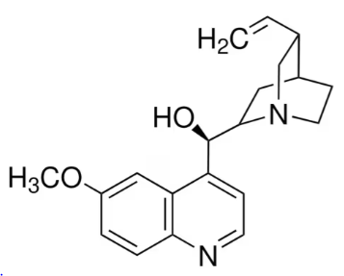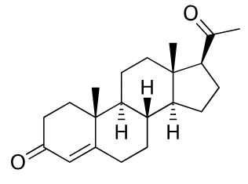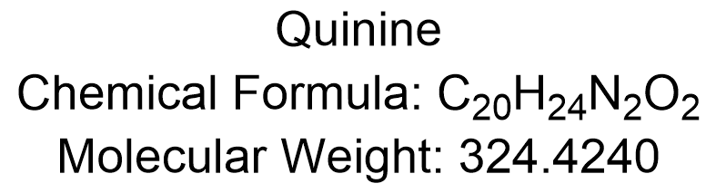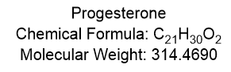

All spectra were recorded in November 2024 on a Varian AS400 spectrometer (Langelandsgade 140, 1513) using CDCl₃ (99.8% deuterated) from Eurisotop.

The following pulse sequences were employed:
• ¹H NMR - zg30
• ¹³C NMR - zgpg30
• ¹H-¹H COSY - cosygpppqf
• ¹H-¹³C HSQC - hsqcedetgpsisp2.3
• ¹H-¹³C HMBC - hmbcgplpndqf

¹H NMR comparison of 8 and 16 scans at low concentrations:
¹H NMR (400 MHz, CDCl₃) of quinine at 1 and 5 mM, each with both, 8 and 16 scans.

¹³C NMR at 100 mM run with 128 scans/7:32 m:s:
¹H NMR (400 MHz, CDCl₃) of quinine at 100 mM with 8 scans/51 s.
¹³C NMR (101 MHz, CDCl₃) of quinine at 100 mM with 128 scans/7:32 m:s.
¹H NMR (400 MHz, CDCl₃) of progesterone at 100 mM with 8 scans/0:51 s.
¹³C NMR (101 MHz, CDCl₃) of progesterone at 100 mM with 128 scans/7:32 m:s.
Full characterization data including ¹H, ¹³C, COSY, HSQC and HMBC at 50 mM:
¹H NMR (400 MHz, CDCl₃) of quinine at 50 mM with 8 scans/0:51 s.
¹³C NMR (101 MHz, CDCl₃) of quinine at 50 mM with 345 scans/19:55 m:s.
¹H-¹H COSY (400 MHz, 400 MHz, CDCl₃) of quinine at 50 mM with 2 scans/10:12 m:s.
¹H-¹³C HSQC (400 MHz, 101 MHz, CDCl₃) of quinine at 50 mM with 2 scans/15:43 m:s.
¹H-¹³C HMBC (400 MHz, 101 MHz, CDCl₃) of quinine at 50 mM with 4 scans/15:32 m:s.

¹H NMR (400 MHz, CDCl₃) of progesterone at 50 mM with 8 scans/0:51 s.
¹³C NMR (101 MHz, CDCl₃) of progesterone at 50 mM with 345 scans/19:55 m:s.
¹H-¹H COSY (400 MHz, 400 MHz, CDCl₃) of progesterone at 50 mM with 2 scans/10:12 m:s.

¹H-¹³C HSQC (400 MHz, 101 MHz, CDCl₃) of progesterone at 50 mM with 2 scans/15:43 m:s.
¹H-¹³C HMBC (400 MHz, 101 MHz, CDCl₃) of progesterone at 50 mM with 4 scans/15:32 m:s.

