Abstract

Covalent Protein Kinase Inhibitors: Exploring Understudied Targets and Unconventional Binding Modes
Protein kinases have been pursued as drug targets for more than 20 years, but a significant part of the human “kinome” has not yet been addressed with specific inhibitors, despite its likely medical relevance. Our research group focuses on the identification of new covalent inhibitors for both validated and understudied protein kinases.
Through our recent work, we and our collaborators have employed rational design approaches as well as intact-protein mass spectrometry (MS) screens to explore kinase-inhibitor-like covalent libraries equipped with cysteine and tyrosine/lysine reactive “warheads”. These efforts have yielded a variety of promising hits. In addition to mass spectrometry, we utilized a suite of complementary methods, including thermal shift assays, biochemical enzyme assays, cellular assays, and X-ray crystallography, for further investigation and thorough validation.
My presentation will detail our progress in extending the range of known protein kinase inhibitors, especially focusing on new inhibitors of lesser-studied kinases. Additionally, I will discuss non-conventional binding modes we have identified, which provide a basis for ongoing medicinal chemistry optimization. These results help to unlock a broader range of kinase targets and support current and future efforts in kinase inhibitor development.

Biosketch Matthias Gehringer
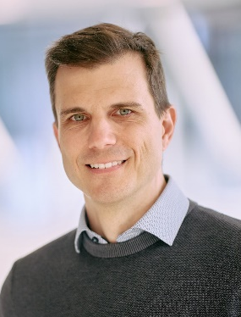
Matthias studied chemistry at the Karlsruhe Institute of Technology (KIT; Germany), the Ecole Nationale Supérieure de Chimie de Montpellier (ENSCM; France), and the University of Heidelberg (Germany). He obtained his doctorate from the University of Tübingen (Germany) where he worked in the group of Prof. Stefan Laufer on reversible and irreversible inhibitors of the protein kinase JAK3. As a postdoc at the Swiss Federal Institute of Technology (ETH) Zürich (with Prof. Karl-Heinz Altmann), he focused on the total synthesis of complex natural products from the mycolactone family. In 2019, he was appointed as Assistant Professor for Medicinal Chemistry at the Institute of Pharmaceutical Sciences, University of Tübingen. In May 2024, he was appointed as Full Professor and head of the Division for Medicinal Chemistry at the Institute of Biomedical Engineering of the Faculty of Medicine, University of Tübingen. Matthias is a Principal Investigator (PI) in the Cluster of Excellence "Image Guided and Functionally Instructed Tumor Therapies (iFIT)".
His research focuses primarily on covalent protein kinase inhibitors and novel approaches for the covalent targeting of cysteine and other amino acids. He received a variety of awards including the Young Investigator Award of the German Pharmaceutical Society and recently the Phil Portoghese Lectureship Award of the American Chemical Society MEDI division. Notably, Matthias is currently heading a European Federation for Medicinal Chemistry and Chemical Biology (EFMC) Best Practices initiative on covalent drug modalities.

