

**Industry 4.0 Enhanced Digital Product Passports and Circular Economy**

**Dataspaces for Sustainable Bio-Based Industries**

**Following the given instructions on the social media guide for June 2025:**

General information on partner/ role in the project

* About [Partner Name]
* Role in bi0SpaCE
* Expectations & Goals

**CARTIF June 2025 – Social Media contribution**

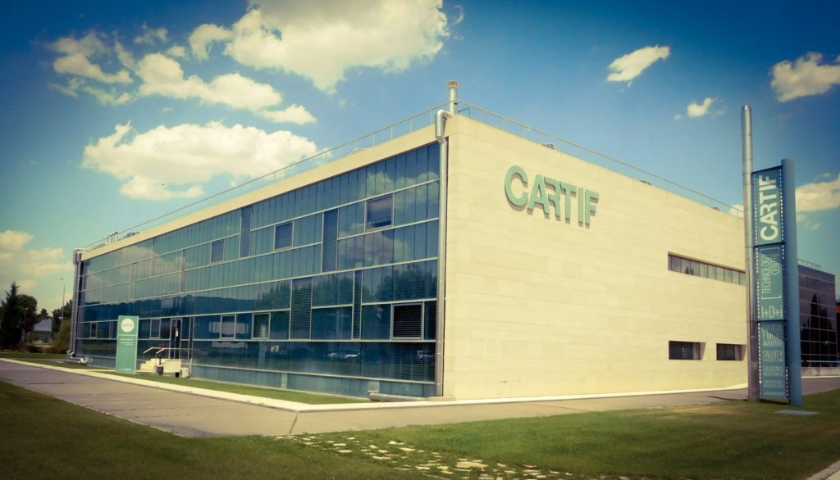

We are proud to collaborate with **Fundación CARTIF**, one of **Spain’s** leading **applied research centres**. Located in Boecillo (Valladolid), **CARTIF** combines multidisciplinary **R&D&I expertise** with a mission to **promote sustainable technological development and innovation** in European industry.

As part of the **bi0SpaCE** project, CARTIF is leading the development of **digital tagging solutions** that will enable the identification and traceability of sustainability and circularity information throughout the life cycle of bio-based products. This work will support more transparent and data-driven green claims across industrial value chains.

CARTIF's contribution includes:

* Designing and implementing **data interoperability mechanisms** across digital platforms.
* Contributing to the development of the **Circular Economy (CE) Dataspace**, in compliance with International Dataspace standards (IDS).
* Participating in **demonstration activities** in real industrial environments focused on **bioplastics**, **aloe vera-based products**, and **paper production**.

CARTIF expects bi0SpaCE to accelerate the digital and circular transition of bio-based value chains, enabling more robust, verifiable, and efficient sustainability data management.

